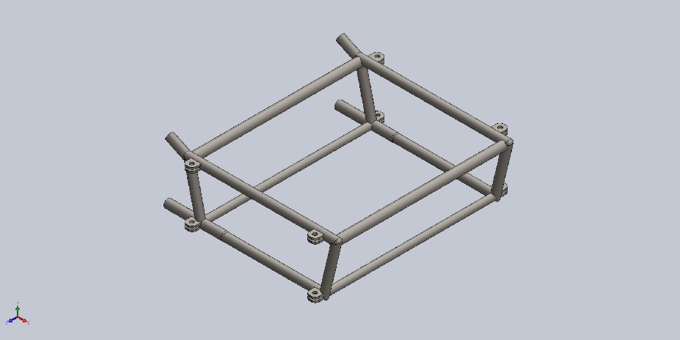 | Simulation of ShelledModel1  Date: April 1, 2023  Designer: Solidworks  Study name: Static 5  Analysis type: Static  Table of Contents  Description 1  Assumptions 2  Model Information 2  Study Properties 3  Units 3  Material Properties 4  Loads and Fixtures 5  Connector Definitions 5  Contact Information 6  Mesh information 7  Sensor Details 8  Resultant Forces 8  Beams 8  Study Results 9  Conclusion 11

Description
No Data

Assumptions

Model Information

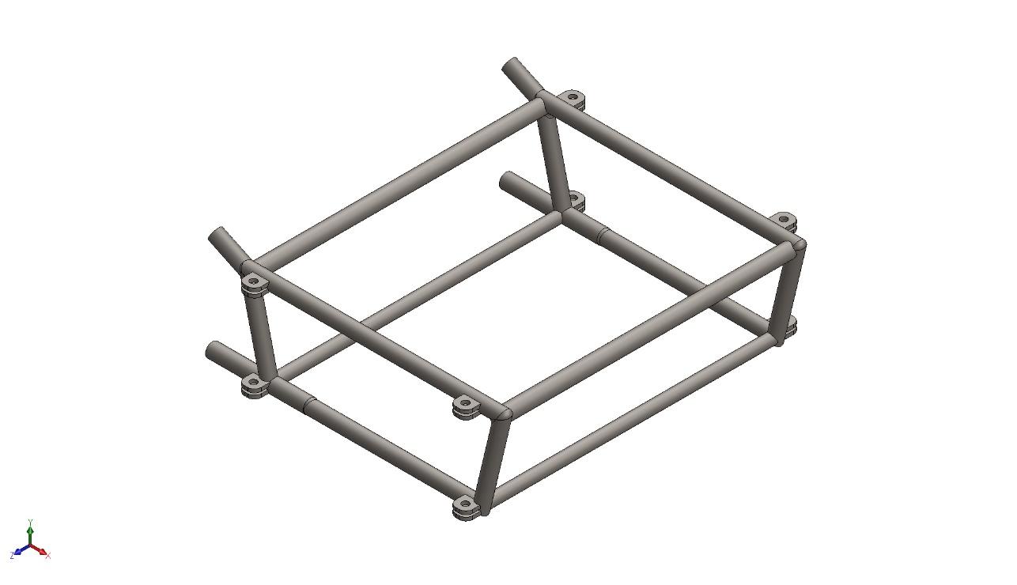
Model name: ShelledModel1
Current Configuration: Default
Solid Bodies
Document Name and Reference | Treated As | Volumetric Properties | Document Path/Date Modified
Mirror4  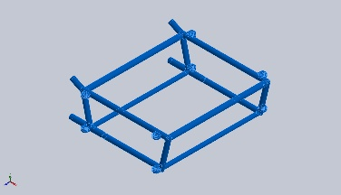 | Solid Body | Mass:8.72198 kg  Volume:0.00111137 m^3  Density:7,847.94 kg/m^3  Weight:85.4754 N | C:\Users\westy\OneDrive\Documents\SubFrame Documents\Frame_Documents\ShelledModel1.SLDPRT  Mar 30 12:43:40 2023

Study Properties
Study name | Static 5
Analysis type | Static
Mesh type | Solid Mesh
Thermal Effect: | On
Thermal option | Include temperature loads
Zero strain temperature | 298 Kelvin
Include fluid pressure effects from SOLIDWORKS Flow Simulation | Off
Solver type | FFEPlus
Inplane Effect: | Off
Soft Spring: | Off
Inertial Relief: | Off
Incompatible bonding options | Automatic
Large displacement | Off
Compute free body forces | On
Friction | Off
Use Adaptive Method: | Off
Result folder | SOLIDWORKS document (C:\Users\westy\OneDrive\Documents\SubFrame Documents\Frame_Documents)

Units
Unit system: | SI (MKS)
Length/Displacement | mm
Temperature | Kelvin
Angular velocity | Rad/sec
Pressure/Stress | N/mm^2 (MPa)

Material Properties
Model Reference | Properties | Components
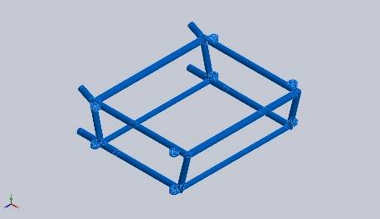 | Name: AISI 4130 Steel, normalized at 870C  Model type: Linear Elastic Isotropic  Default failure criterion: Max von Mises Stress  Yield strength: 460 N/mm^2  Tensile strength: 731 N/mm^2  Elastic modulus: 205,000 N/mm^2  Poisson's ratio: 0.285  Mass density: 7.85 g/cm^3  Shear modulus: 80,000 N/mm^2 | SolidBody 1(Mirror4)(ShelledModel1)
Curve Data:N/A

Loads and Fixtures
Fixture name | Fixture Image | Fixture Details
Fixed-1 | 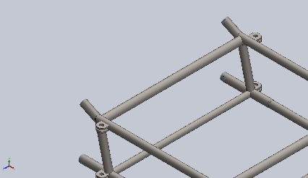 | Entities: 4 face(s)  Type: Fixed Geometry
Resultant Forces
Components | X | Y | Z | Resultant
Reaction force(N) | 0.0191936 | 160.849 | 0.00788128 | 160.849
Reaction Moment(N.m) | 0 | 0 | 0 | 0

Load name | Load Image | Load Details
Distributed Mass-1 | 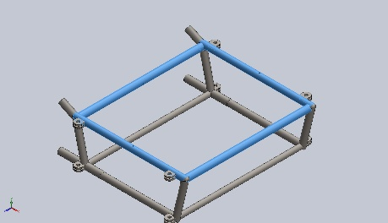 | Entities: 4 face(s)  Type: Displacement (Direct transfer)  Coordinate System: Global cartesian coordinates  Translation Values: ---, ---, --- mm  Rotation Values: ---, ---, --- deg  Reference coordinates: 0 0 0 mm  Remote Mass: 7.7 kg  Moment of Inertia: 0,0,0,0,0,0 kg.m^2  Components transferred: NA
Gravity-1 | 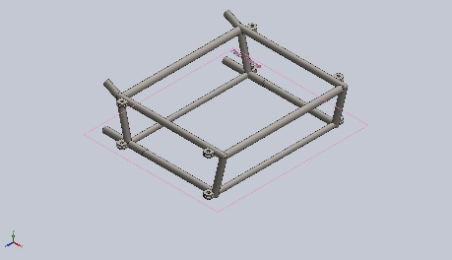 | Reference: Top Plane  Values: 0 0 -9.81  Units: m/s^2

Connector Definitions
No Data

Contact Information
No Data

Mesh information
Mesh type | Solid Mesh
Mesher Used: | Standard mesh
Automatic Transition: | Off
Include Mesh Auto Loops: | Off
Jacobian points for High quality mesh | 16 Points
Element Size | 10.361 mm
Tolerance | 0.518051 mm
Mesh Quality | High

Mesh information - Details
Total Nodes | 21826
Total Elements | 11009
Maximum Aspect Ratio | 19.259
% of elements with Aspect Ratio < 3 | 92.8
Percentage of elements with Aspect Ratio > 10 | 0.109
Percentage of distorted elements | 0
Time to complete mesh(hh;mm;ss): | 00:00:05
Computer name: | JOSH-G15
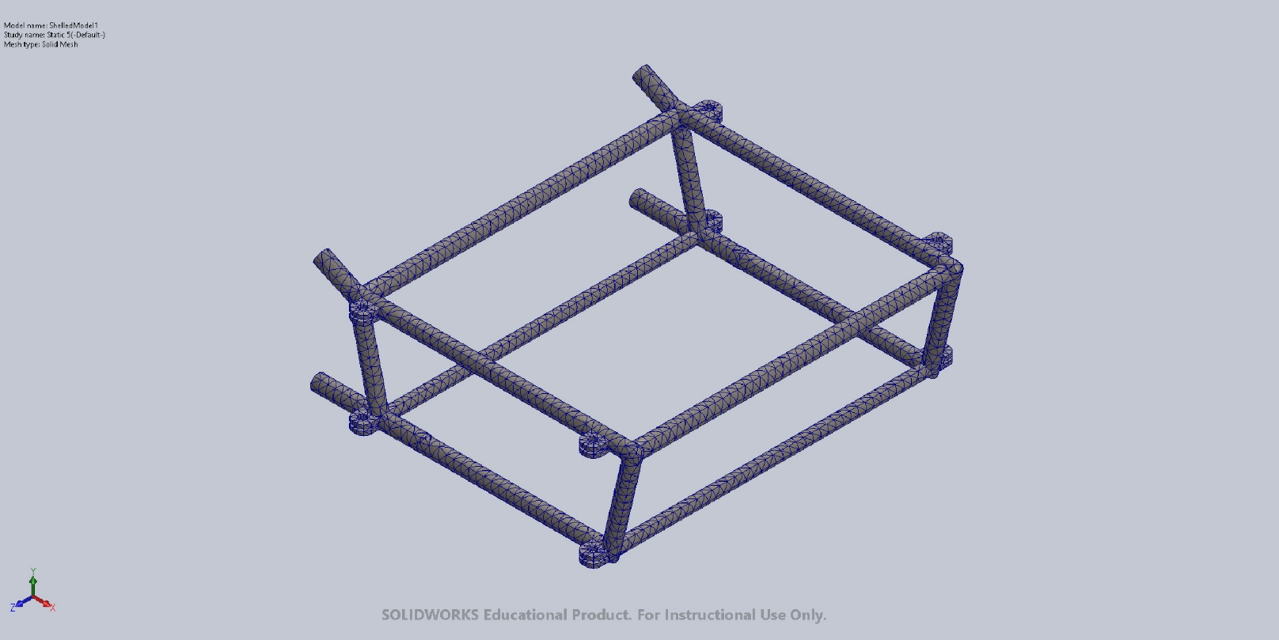

Sensor Details
No Data

Resultant Forces

Reaction forces
Selection set | Units | Sum X | Sum Y | Sum Z | Resultant
Entire Model | N | 0.0191936 | 160.849 | 0.00788128 | 160.849

Reaction Moments
Selection set | Units | Sum X | Sum Y | Sum Z | Resultant
Entire Model | N.m | 0 | 0 | 0 | 0

Free body forces
Selection set | Units | Sum X | Sum Y | Sum Z | Resultant
Entire Model | N | -0.137809 | 56.7884 | -0.0657987 | 56.7886

Free body moments
Selection set | Units | Sum X | Sum Y | Sum Z | Resultant
Entire Model | N.m | 0 | 0 | 0 | 1e-33

Beams
No Data

Study Results

Name | Type | Min | Max
Stress1 | VON: von Mises Stress | 2.890e-03N/mm^2 (MPa)  Node: 11640 | 7.336e+00N/mm^2 (MPa)  Node: 12816
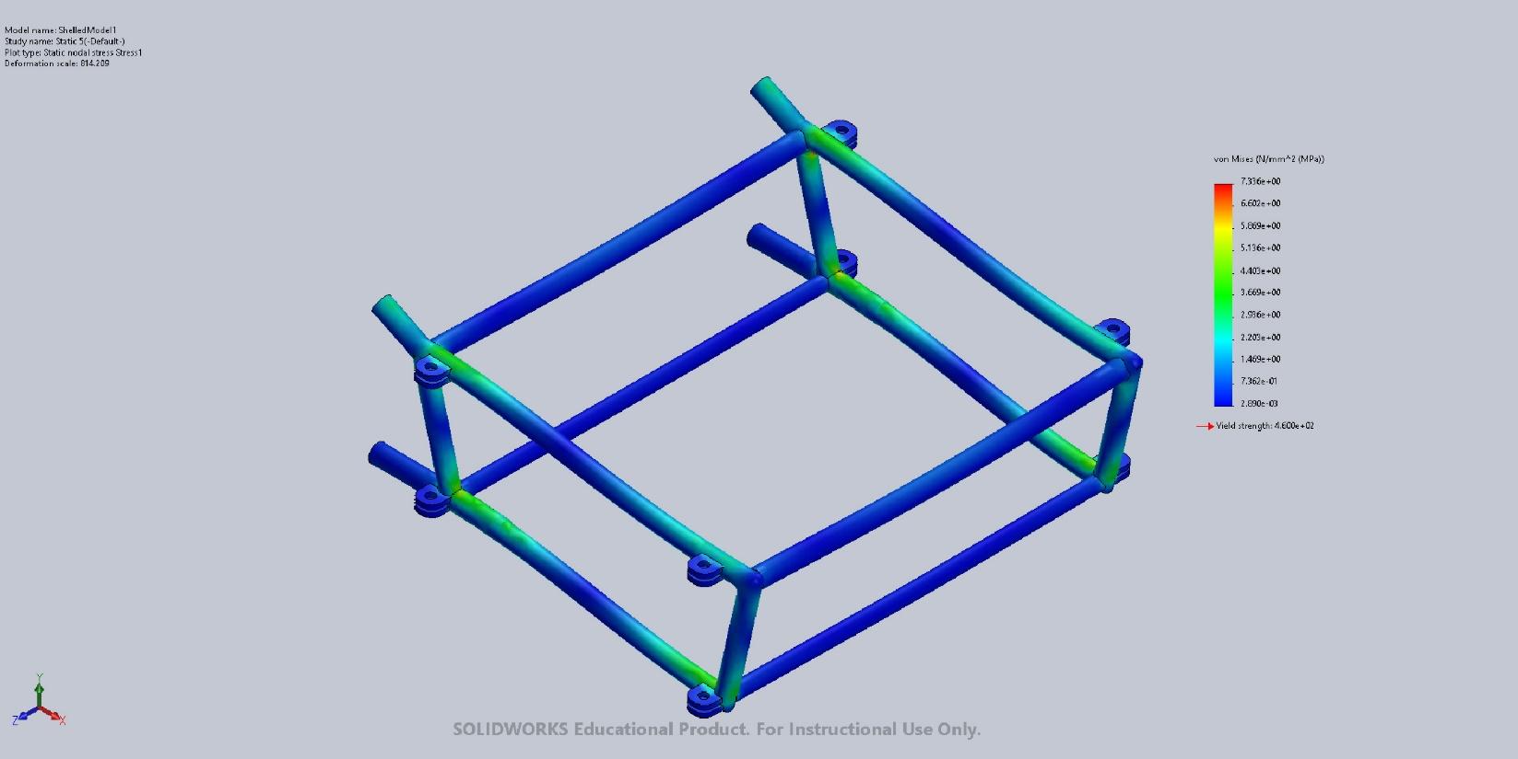
ShelledModel1-Static 5-Stress-Stress1

Name | Type | Min | Max
Displacement1 | URES: Resultant Displacement | 0.000e+00mm  Node: 259 | 6.042e-02mm  Node: 993
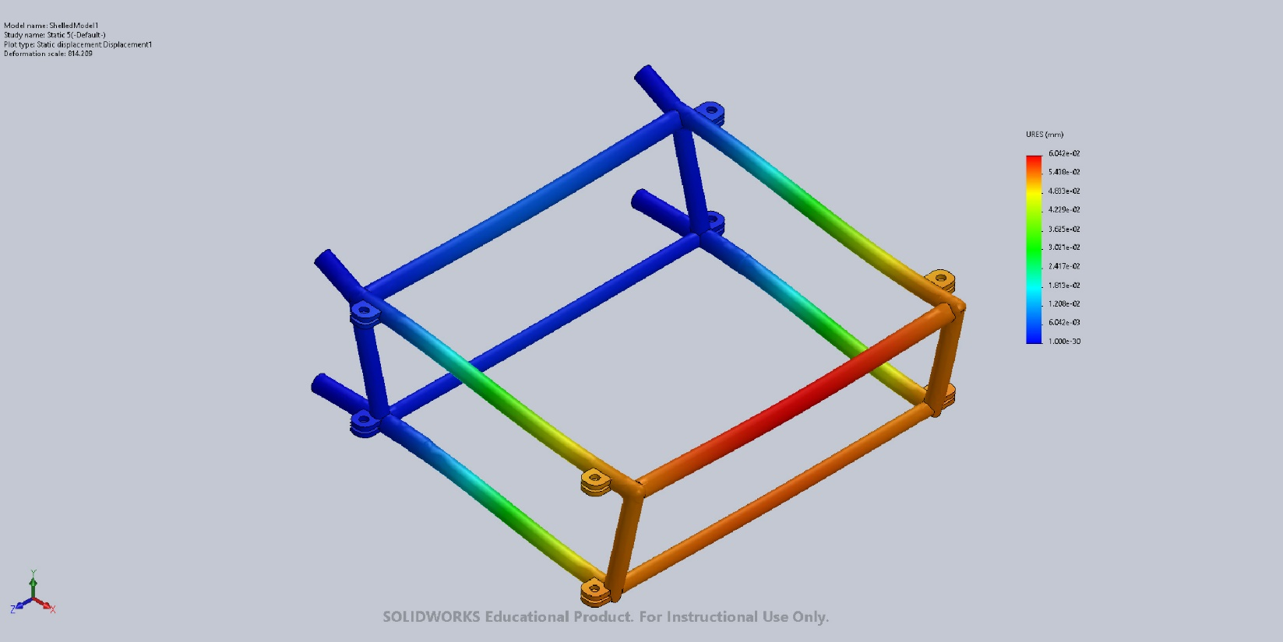
ShelledModel1-Static 5-Displacement-Displacement1

Name | Type | Min | Max
Strain1 | ESTRN: Equivalent Strain | 3.681e-08  Element: 986 | 2.281e-05  Element: 2566
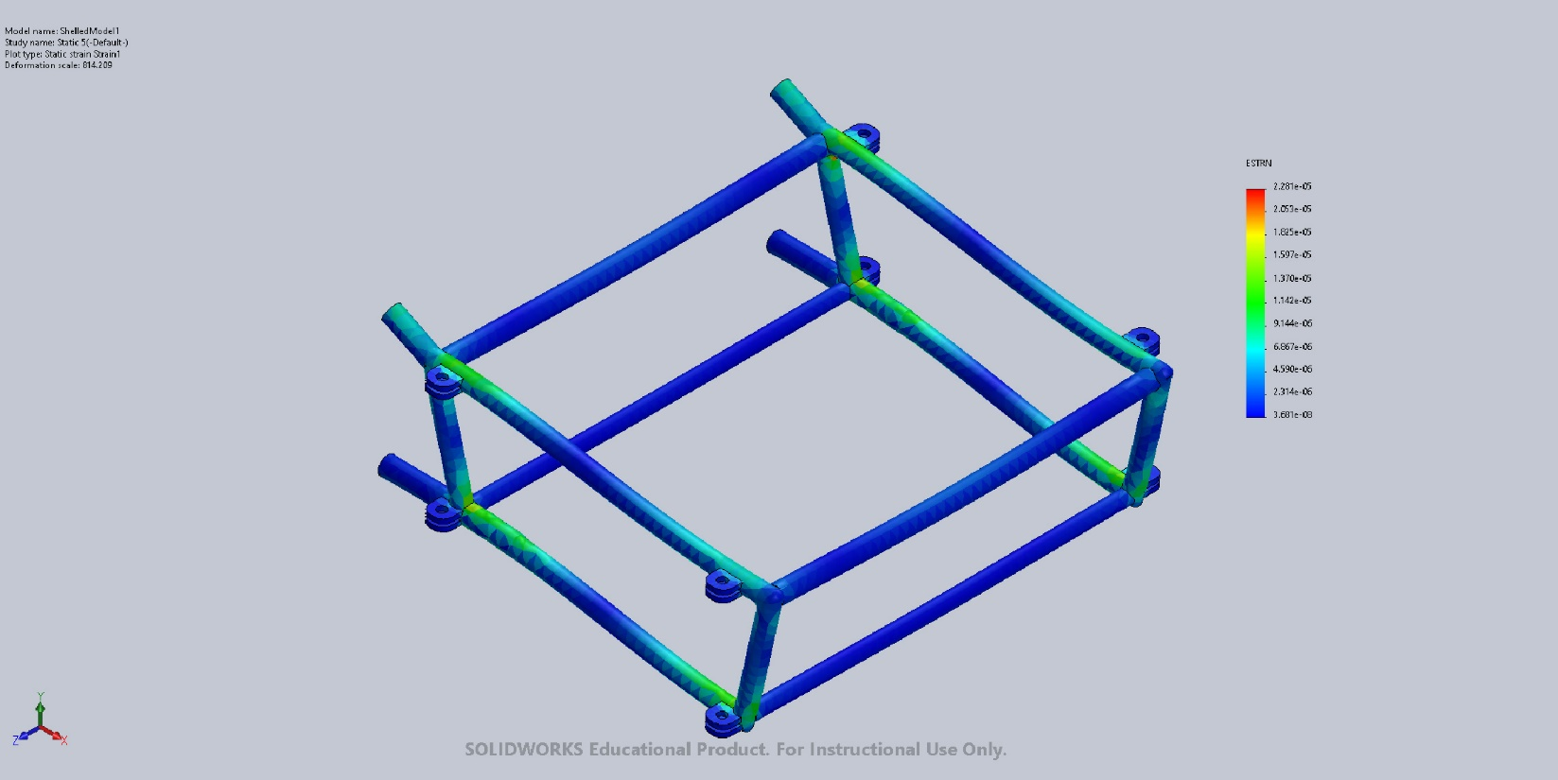
ShelledModel1-Static 5-Strain-Strain1

Name | Type | Min | Max
Factor of Safety1 | Max von Mises Stress | 3.000e+00  Node: 1 | 3.000e+00  Node: 1
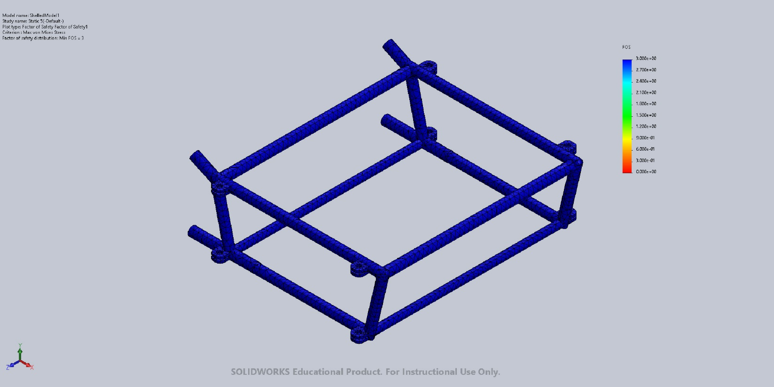
ShelledModel1-Static 5-Factor of Safety-Factor of Safety1

Conclusion

